**Messaging Server Software Architecture**

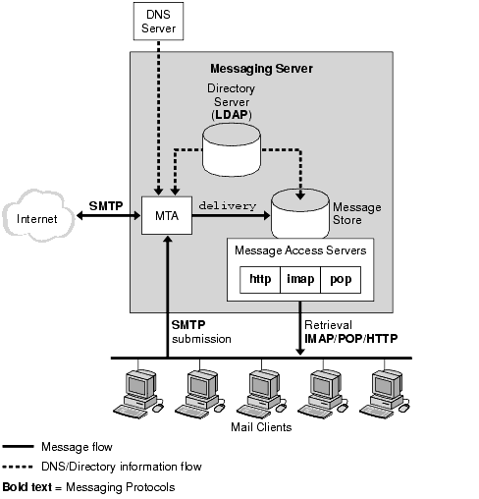

The preceding figure shows the following Messaging Server software components:

* **Message Transfer Agent or MTA.** Receives, routes, transports, and delivers mail messages using the SMTP protocol. An MTA is like an electronic mail deliverer dispersing messages to an electronic mailbox or to another MTA.
* **Message Store.** Consists of a set of components that store, retrieve, and manipulate messages for mail clients. Mail can be retrieved by POP, IMAP, or HTTP clients. POP clients download messages to the client machine for reading and storage. IMAP and HTTP clients read and store messages on the server. The Message Store is like an electronic mailbox that stores and retrieves mail for users.
* **LDAP directory.**Stores, retrieves, and distributes mail directory information for Messaging Server. This includes user routing information, distribution lists, configuration data, and other information necessary to support delivery and access of email. The LDAP directory is a directory of mail addresses, aliases, routing information, passwords, and any information needed by the MTA or Message Store to deliver and retrieve messages.
* **DNS Server.**Translates domain names into IP addresses. This component needs to be present before Messaging Server is installed.